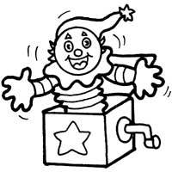

**Song: Solving an Equation**

**(Tune: Pop! Goes the Weasel)**

**GOAL:** To get the variable by itself

First you **BOX t**he variable

**CANCEL** what’s beside it

**CANCEL** what’s inside the box,

**REDUCE!** And you’ve Solved it!