A _____________________ is a rule which relates each element of a set with exactly one element of another set. In other words, it relates an __________________ to an ____________________.
repeat
output (y)
input (x)
function
This means that none of the x-values can ________________.

Determining if a relation is a function. (just make sure an x does not repeat!)

Ordered Pairs:
Ex 1) {(3, 4),(0,3), (1,8), (0,2)} Check: Do any of the x-values repeat? If they do, it is NOT a function!!
Is it a function? ________

Ex 2) {(8, 3),(2,7),(1,2),(5,3)} Check: Do any of the x-values repeat? If they do, it is NOT a function!!
Is it a function? ________

Tables:
X | 2 | 5 | 9
Y | 13 | 9 | 13
Ex 3) Check: Do any of the x-values repeat? If they do, it is NOT a function!!
Is it a function? _________

x | Y
2 | 4
5 | 7
2 | 9
Ex 4) Check: Do any of the x-values repeat? If they do, it is NOT a function!!
Is it a function? _________

Mappings:

Ex 4) To determine if a mapping is a function: Each x value can only be used ONCE!!!
2
4
6
1

5
Is it a function? ________

Ex 4) To determine if a mapping is a function: Each x value can only be used ONCE!!!
5
3
8
4
1
Is it a function? ________

Graphs:
Another way to determine if a relation is a function: Vertical Line Test
Vertical line
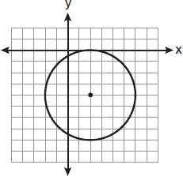
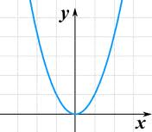
On a graph, it is a function if a __________________________ would ever cross the graph ____________________________________.
only one time
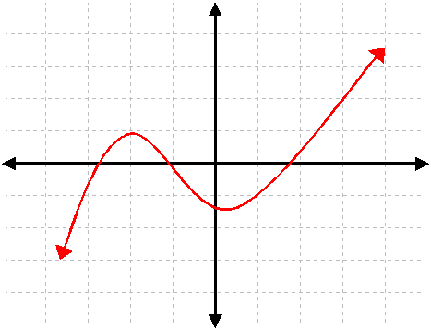
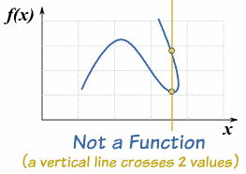
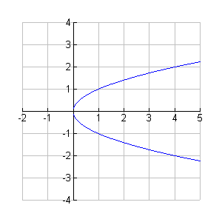

_______________ ______________ _______________ _______________

Some Examples of Functions

x² is a function

5x – 6 is a

function

x³+1 is a function

Verbal Descriptions:
To decide if a verbal description of a relation is a function: “Does each x have only ONE y?”

Ex 6) (state, capital) Check: Does each state have only ONE capital? Is it a function?_________

Ex 7) (state, city) Check: Does each state have only ONE city? Is it a function?_________

Create examples of functions and non-functions!
_{Ordered Pairs}  (___,____),(____,____),  (___,____),(____,____)  Functions-> | _{Table}  x  y | _{Mapping} | _{Graph}
_{Ordered Pairs}  (___,____),(____,____),  (___,____),(____,____)  Not Functions-> | _{Table}  x  y | _{Mapping} | _{Graph}
Is it a function? Write YES or NO in each blank
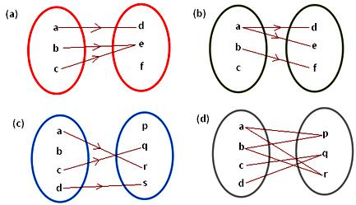
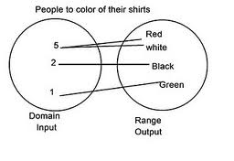
1. 2.

3. {(3, 5),(1, 5), (9, 5), (0, 5)} ______ 4. {(0, 0), (2, 2), (4, 4)} ______
b.
a.
month | height
March | 5’8”
April | 5’10”
June | 5’4”
March | 5’5”
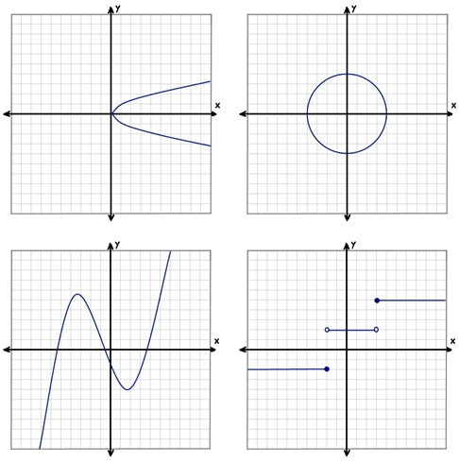
5. 6.
d.
c.
b.
a.

