Write the linear equation in slope-intercept form given the following information.

1. The slope is 4 and the y-intercept is 2: ___________________________

2. m = 5, b = -1: ________________________________________________

3. slope is ½ and it crosses the y-axis at -3 ___________________________

4. rate of change is -3 and the y-intercept is (0, 7) _____________________

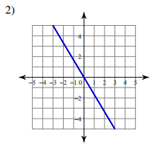
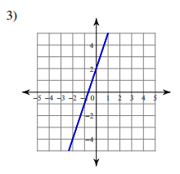
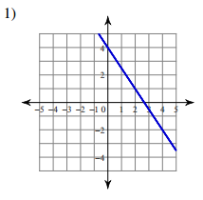
Identify m and b on the graph and write the liner EQuation in slope-intercept form.

m = _____ b = _____ m = _____ b = _____ m = _____ b = _____
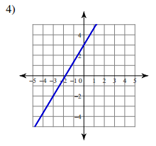
EQ:_______________ EQ:_______________ EQ:_______________
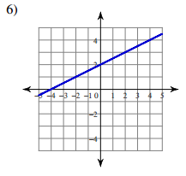
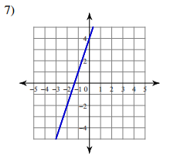

m = _____ b = _____ m = _____ b = _____ m = _____ b = _____
EQ:_______________ EQ:_______________ EQ:_______________
Solve for y. Then identify m and b.

1.) 3y = 15x – 12 2.) 5x – 10y = -10 3.) 3y – 21 = 12x

m = _____ b = _____ m = _____ b = _____ m = _____ b = _____

4.) 3y - 2 = – 3x 5.) -2x - 6y = 18 4.) 2x + 5y = 20

m = _____ b = _____ m = _____ b = _____ m = _____ b = _____

7.) 2x + 3y = 3 8.) 5y – 10 = x 9.) 2(4x – 2y) = -4

m = _____ b = _____ m = _____ b = _____ m = _____ b = _____

Answer Bank: (there will be one equation in the answer bank you will not need to use)
Y = -$\frac{1}{3}$x - 3 | Y = -$\frac{2}{3}$x + 1 | Y = $\frac{1}{2}$x + 1 | Y = -$\frac{2}{3}$x + 2 | Y = 4x + 7
Y = 2x + 1 | Y = 5x - 4 | Y = $\frac{1}{5}$x + 2 | Y = -x + $\frac{2}{3}$ | Y = -$\frac{2}{5}$x + 4

