Proportional Linear Relationships: A straight line that passes through the origin. (NO addition or subtraction!)

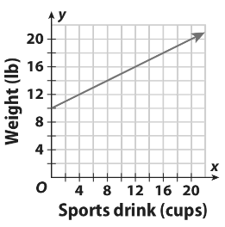
Part I, 8th Grade Review: Decide if the following relationships are proportional or non-proportional.
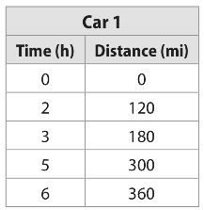
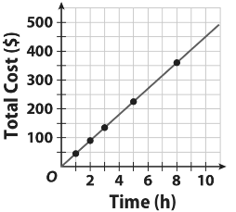
1. 2. 3.

Proportional/Non-Proportional Proportional/Non-Proportional Proportional/Non-Proportional
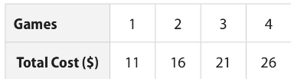
4. 5. y = x - 4 6. y = -2x + 3

Proportional/Non-Proportional Proportional/Non-Proportional Proportional/Non-Proportional
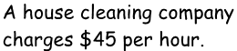
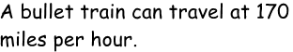
7. 8. 9.

Proportional/Non-Proportional Proportional/Non-Proportional Proportional/Non-Proportional

Part 2: When given 3 numbers, set up a proportion, cross multiply and divide.
Direct Variation | A proportional relationship represented by the equation $y=ax$, where  - y varies directly with x  - “$a$” represents the slope or “constant of variation”.  - Passes through the origin…..y-intercept = 0.

ex: y varies directly with x. If $y=3.75$ when $x=15$, then what is the value of x when $y=7.5$?
1. Set up a proportion: $\frac{y}{x }$ = $\frac{y}{x }$ $\frac{3.75}{15 }$ = $\frac{7.5}{x }$
(divide by the number diagonal from the variable)
2. Cross multiply & Divide: (15)(7.5) ÷ 3.75
x = 30
10. The number $s$ of tablespoons of sea salt needed in a saltwater fish tank varies directly with the number $w$ of gallons of water in the tank. A pet shop owner recommends that you add 100 tablespoons of salt to a 20-gallon tank. How many tablespoons of salt should you add to a 30-gallon tank?

11. The ordered pair (5, 6) is a solution of a direct variation equation. Find y when x = 15.

12. The number of calories in a container of orange juice varies directly with the number of ounces of orange juice in the container. A 12-ounce container of orange juice has 168 calories. How many calories are in a 32-ounce container of the same orange juice?

13. The weight of an object on Pluto varies directly with the weight of an object on Earth. If an object weighs 100 pounds on Earth and 6 pounds on Pluto, then what would a boulder that weighs 45 pounds on Pluto weigh on Earth?

Domain and Range Practice:
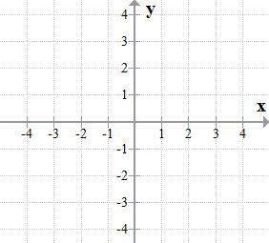
14. What is the domain: {(34, -17), (47, -23), (52, -11), (65, -4)} _____________________________
15. 16. 17. Jared’s baseball bag only has
one bat that weighs 31 ounces and 4 baseballs that weigh 5.25 ounces each. y =5.25x + 31 finds the total weight (y) and for the number of baseballs (x). Find the range?

Domain:______________ Domain:______________ Range = {_____, _____, _____, _____}

Solving for x: (set up the equation then, distribute, combine, and Solve)
18. A triangle has a perimeter of 50. The lengths of the sides are x + 5 and 2x and 3(1 + x). Find the value of x.
perimeter
side
side
side
_______________ + __________________ + __________________ = ________
distribute:
combine:
solve:

