Name Date

Scatter Plots and Lines of Fit

4.5 & 4.6

**In Exercises 1 - 3, tell whether *x* and *y* show a *positive*, a *negative*, or *no* correlation.**

1. ________________ 2. ________________ 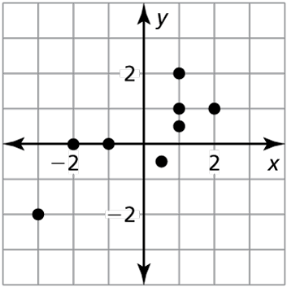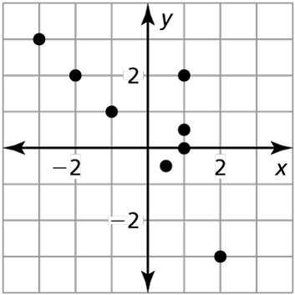  **3**. ________________

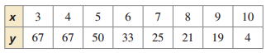

**4.** Explain your answer in #3.

**5.** Give an example of a real-life data set that shows a negative correlation.

**In Exercise 6 - 9, match each correlation coefficient with its graph. Then, interpret the strength of linear association.**

____ 6. , ______________

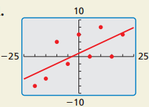

D.

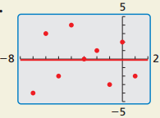

C.

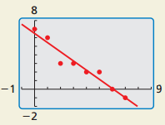

B.

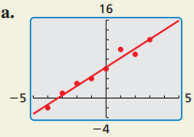

A.

____ 7. $r=0.98$, ______________

____ 8. $r=-0.97$, ______________

____ 9. $r=0.69$, ______________

In Exercises 10 and 11, use a graphing calculator to find an equation of the line of best fit for the data. Identify and interpret the correlation coefficient. (Round to the hundredths place.)

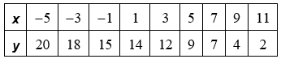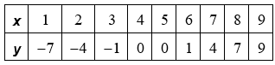 10. 11.

Line of Best Fit: Line of Best Fit:

Correlation Coefficient: Correlation Coefficient:

Measure of Strength: Strong Positive/Strong Negative/ Measure of Strength: Strong Positive/Strong Negative/

No Corr/Weak Positive/Weak Negative No Corr/Weak Positive/Weak Negative

12. The table shows the number *y* of pineapple plants in a garden *x* years since 2004.

|  |  |  |  |  |  |
| --- | --- | --- | --- | --- | --- |
| *x* | 2 | 3 | 4 | 7 | 8 |
| *y* | 4 | 7 | 9 | 15 | 16 |

1. Make a scatter plot of the data.
2. What type of correlation? Positive/Negative/No Correlation
3. Draw a trend line.
4. 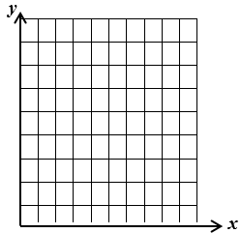Use a calculator to find the equation of the line of best fit that models the approximate number of pineapple plants as a function of the number of years since 2004 using the points (Round to the hundredths place if needed.)

**e.** Interpret the slope and *y*-intercept of the line of best fit.

Slope: *y*-intercept:

**f.** Find the correlation coefficient, $r$:  **g.** Determine the strength of the correlation coefficient.

h. Predict the number of pineapple plants in 2024.

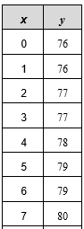13. The table shows the number of people *x* in a room and the temperature in the room in degrees Fahrenheit, *y*. (Round to the hundredths place.)

1. Using a calculator, find an equation of the line of best fit.
2. Identify and interpret the correlation coefficient.

Correlation Coefficient: Strength:

1. Approximate the temperature when 15 people are in the room.

d. Predict the number of people in the room when the temperature is 95.

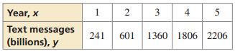

14. The table shows the numbers $y$ (in billions) of text messages sent each year in a five-year period, where $x = 1$ represents the first year in the five-year period.

1. Use a graphing calculator to find an equation of the line of best fit.
2. Identify and interpret the correlation coefficient.

Correlation Coefficient: Strength:

1. Predict the number of text messages in the 10th year.

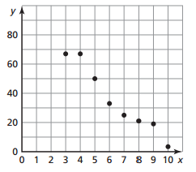

14. Which of the following best approximates the line of best fit for the given scatter plot?

A $y= -15x+90$

B $y=-10x+110$

C $y=-13x+98$

D $y=-9.6x+98$

**In Exercises 15–17, tell whether a correlation is likely in the situation. If so, tell whether there is a causal relationship. Explain your reasoning.**

**15.** the amount of time spent talking on a cell phone and the remaining battery life

Correlation: Causation: YES/NO Explanation:

**16.** the height of a toddler and the size of the toddler’s vocabulary

Correlation: Causation: YES/NO Explanation:

**17.** the number of hats you own and the size of your head

Correlation: Causation: YES/NO Explanation:

**STAAR Review:**

**18.** Given: $p(x) = 2x - 10$

Identify: Slope: $y$_______ -intercept: _______ What is the zero of the function? **_______**

**19.** Evaluate $f(x) = 6x$, **20.** Evaluate $h(x)=5-3x$, **21.** Evaluate $v\left(x\right)=-10x$,

when $x=-3$ when $x = 0$ when $v(x)=5$