1. The table shows the weekly sales of a DVD and the number of weeks since its release.

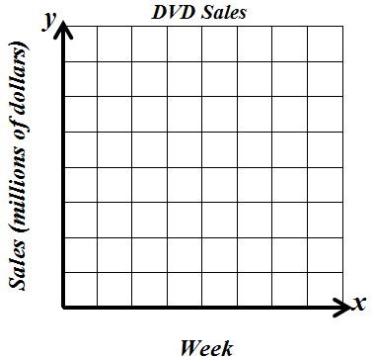
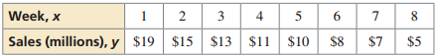

- Make a scatter plot of the data.

- What type of correlation? Positive/Negative/No Correlation

- Draw a trend line.

d. Use a calculator to find the equation of the line of best fit. (Round to the
hundredths place if needed.)

e. Interpret the slope and y-intercept of the line of best fit.
Slope: y-intercept:

f. Find the correlation coefficient, $r$: g. Determine the strength of the correlation coefficient.

2. The scatter plot shows the days $x$ of practice and the numbers $y$of free throws made during practice.
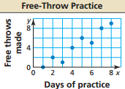
- What type of correlation? Positive/Negative/No Correlation

- Draw a trend line.

c. Use a calculator to find the equation of the line of best fit. (Round to the
hundredths place if needed.)

- Find the correlation coefficient, $r$:

- Determine the strength of the correlation coefficient.

f. Predict the number of free throws made after 10 days of practice.

3. The table shows the durations $x$ (in minutes) of several eruptions of the geyser Old Faithful and the times $y$ (in minutes) until the next eruption.
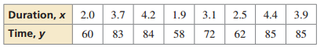

- What type of correlation? Positive/Negative/No Correlation

b. Use a calculator to find the equation of the line of best fit. (Round to the
hundredths place if needed.)

c. Find the correlation coefficient, $r$: d. Determine the strength of the correlation coefficient.

- Approximate the duration before a time of 77 minutes.

f. Predict the time after an eruption lasting 5.0 minutes.

Practice: Tell whether a correlation is likely in the situation. If so, tell whether there is a causal relationship. Explain your reasoning.

4. time spent exercising and the number of calories burned

Correlation: Causation: YES/NO

5. the number of banks and the population of a city

Correlation: Causation: YES/NO

6. time spent playing video games and grade point average

Correlation: Causation: YES/NO

7. Eating organic food and getting a good score on a test

Correlation: Causation: YES/NO

