1. What is the 10th term of a pattern whose rule is 5x + 3? _______

|  |  |
| --- | --- |
| Input | Output |
| 0 | -11 |
| 4 | -15 |
| 6 | -17 |
| 7 | -18 |

2. Write an expression that would create

the following table.

________________________

3. What expression would create the following sequence of numbers? 7, 9, 11, 13, …

_______________________

|  |  |  |
| --- | --- | --- |
| Figure # | Process | # of dots |
| 1 |  |  |
| 2 |  |  |
| 3 |  |  |
| 16 |  |  |
| 55 |  |  |
| n |  |  |

4. Find the nth term for the following table.

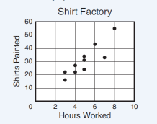

5. What type of correlation does the following

graph have?

__________________________

6. Mr. Hernandez collected data on the number of hours his students practiced and their average golf score. If he graphs the data, what type of correlation should exist?

|  |  |  |  |  |  |
| --- | --- | --- | --- | --- | --- |
| # hours practiced | 4 | 6 | 8 | 10 | 12 |
| Average golf score | 125 | 114 | 108 | 106 | 101 |

_______________________

7. As the number of people who purchase tickets increases, the amount of money made at the concert increases. What type of correlation does this represent?_______________________________________

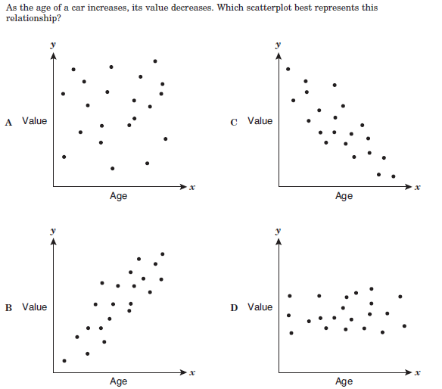8.

9. In the newspaper, Tony read an article about a study done in New Zealand that compared kangaroo tail length with their maximum jumping distance. It stated that there was a positive correlation between the two. Which of the following is the best interpretation of this data?

1. the longer the kangaroos tail, the shorter it jumps
2. the longer the kangaroos tail, the longer it jumps
3. the shorter the kangaroos tail, the longer it jumps
4. tail length and jumping distance are unrelated

10. Draw in the trend line and make a 11. Make a prediction of the number prediction of the number of minutes a person of repetitions a weight-lifter can do needs to exercise in order to burn 300 calories. if he is lifting a 90 pound weight.

_______________________ ___________________________

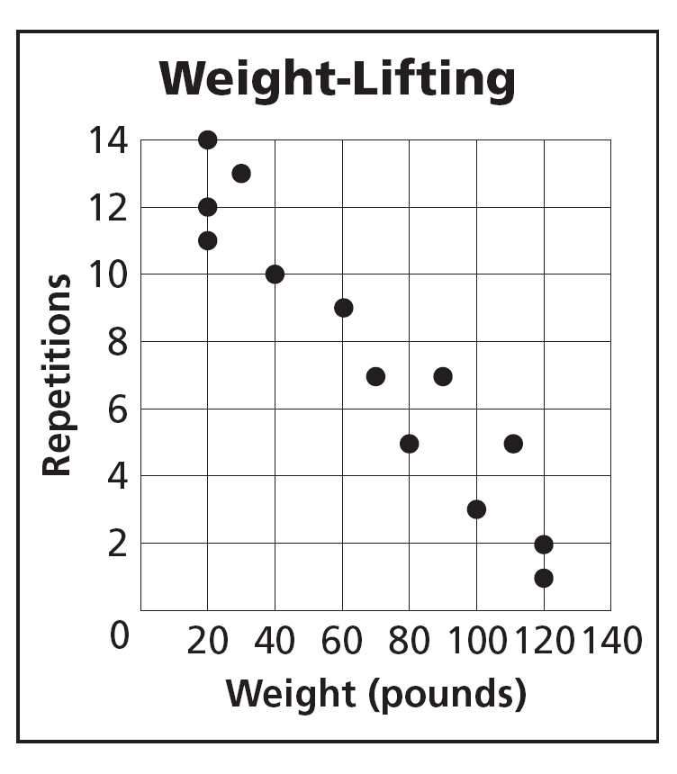

­­­­­­­­­­­­­­­­­­­­­­­­

­­­­­­­­­­­­­­­­­­­­­­­­­

12. Simplify the following expression. 14x + 5y – 8x + 3 + 10x _________________________

13. Simplify the following expression. -2(2x – 3) – 5(x – 6) ___________________________

14. Write the expression: Nine less than the quotient of n and four. ___________________

15. Seth bought a pair of rollerblades for $35. It costs him $175 a year in skate park fees and equipment. Write an expression that will represent his total cost per year to be a rollerblader.

___________________

16. Jaime gave his girlfriend Rosa a $50 gift card for the nail salon. If each manicure (m) cost $15, Which expression would represent the number of manicures (m) that she could go get?

1. 50m – 15
2. 50m + 15
3. 50 + 15m
4. 50 – 15m

17. Given the function y = 2(x + 5) – 3x, find y when (2, y) is a solution. ____________

18. The length of a rectangle is five more than three times its width. If the width of the rectangle is 4 units, what is the length? _________________________

Solve for x.

18. -x – 7 = -9 x = ___________ 19. -5(x + 8) = 4 – x x = ___________

20. The length of a rectangle is 5 inches more than the width. If the perimeter of the rectangle is 38 inches, find the length and width.

21. Susan bought 7 packages of paper at the store for a total of $20.50. The tax on her purchase was $3. Find the price of each package of paper.

22. Complete the examples: of commutative property: x + 4 = ______­­­_____________

of associative property: w + (9 + x) = _________________

of distributive property: 6(w + 5) = __________________

23. Solve: 7y + 8 = 15y – (16y + 24) 24. Solve: x + 5 = – 4

25. Find the value of x in the diagram below. (Hint: Vertical angles are congruent.)

x = _____

(6x + 3)°

(8x – 21)°