Name Date
1st SW
Review

First Six Weeks Review

1. Simplify the expression: 4 - 5(-4x + 3) + x
Things to think about: “simplify” means
- No “=” equal sign, no solving
- Distribute
- Combine Like Terms
- Leave “x” in your answer

Solve the following equations:
2. 8x – 2 = -9 + 7x
Things to think about: “solve” means
- Distribute & Combine Like Terms
- Put Variable Terms on one side
- Put constant terms on the other side
- Solve to find what x is equal to
- (if the variable cancels out, determine if you have NO SOLUTION or INFINITELY MANY SOLUTIONS)

3. 5x + 34 = -2(1 - 7x)

4. Find x if the perimeter is 14.
Things to think about: “perimeter” means
- ADD up all the sides
- So set up your equation, then solve

2x x + 4

x - 2

5. Solve & graph the inequality -4x – 6x > -20
Things to think about: solving “inequalities”
- Solve like an equation
- if you multiply or divide by a negative, flip the inequality sign
- < means LESS THAN

Things to think about: graphing “inequalities”
- < and > have open circles
- < and > have closed circles
- < means LESS THAN

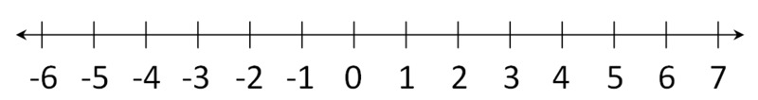

6. The sum of a number x and 2 is at most 5.
Things to think about: “inequality”
- At most 5 means the MOST you can have is 5, you can’t have more than 5.
- At least 5 means the LEAST you can have is 5 you can’t have less thaan 5
- No more than 5 means you cannot have more than 5, but you can have 5
Write and solve the inequality.

7. Solve for y. 8x + 4y = 12
Things to think about: “solving with two variables” (literal equations)
- Box the variable you are solving for
- Cancel beside the box – if they are not like terms, do not combine them!
- Cancel the number in the box – be sure to divide everywhere!!
- Your answer will be an equation

Things to think about: “functions”
- Each input has exactly one output.
- (so x cannot repeat)
8. Is the following relation a function?
{(3, 5), (7, 10), (−1, 0), (−5, 5), (0, 1), (2, 5)}

Things to think about: “domain”
- Domain is all the x values
- If the function is discrete (countable), you can list the domain, use { }
- If you are given plotted points, first write the ordered pairs.
9. What is the domain of the following functions?
a. {(2, 5), (3, 10), (3.5, 12), (5, 25)}

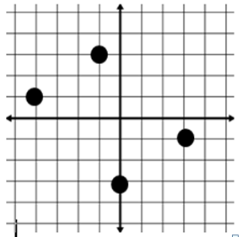
Things to think about: “domain”
- Domain is all the x values
- If the domain is continuous (measured), use inequalities (like 2 < x < 10 or x > 4)
- Domain goes from LEFT to RIGHT
- Open circles: < or >
- Closed circles: < or >
b.

10. Find the range of the following functions:
Things to think about: “range”
- Range is all the y values
- If the function is discrete, you can list the range, use { }
- If the range is continuous, use inequalities (like 2 < y < 10 or y > 4)
- Range goes from BOTTOM to TOP
- Open circles: < or >
- Closed circles: < or >
- If you are given plotted points, first write the ordered pairs.
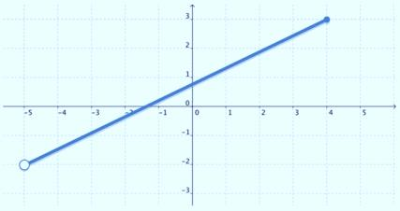
a.

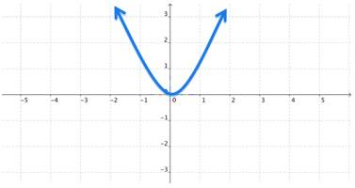
b.

11. Which table represents a linear function?
Things to think about: “linear”
- The elements in the domain must have a constant rate of change
- The elements in the range must have a constant rate of change
- So all the x’s must “count by the same number” and all the y’s must “count by the same number”
- If it is not linear, it is NONLINEAR.

x | y
1 | 4
2 | 7
3 | 10
4 | 13
.
x | y
1 | 4
2 | 6
3 | 8
4 | 12

Things to think about: “function notation”
- To write in function notation, replace “y” with “f(x)”
12. Write the equation, y = -3x + 10 in
function notation.

Things to think about: “function notation”
- To evaluate in function notation, the number in the parenthesis( ) is x.
- Plug x into the equation and solve.
13. If f(x) = -3x + 5,
find the following value: f(-2) =

14. Use the graph to find the value of f(-2).
Things to think about: “function notation”
- To evaluate in function notation using a graph, the number inside the parenthesis ( ) is x.
- Use the graph t find the corresponding y-value for each x-value.

15. Find the slope and state what is represents.
Things to think about: “slope”
- Slope is the tilt/slant of a line
- It is also called the rate of change.
- m = $\frac{rise}{run}= \frac{change in y}{change in x}=\frac{∆y}{∆x}$
- $\frac{miles}{gallons}$ Top unit depends on the bottom unit (Ex.: miles depend on gallons, also read: miles PER gallon)
- $\frac{y_{2}-y_{1}}{x_{2}-x_{1}}$ for 2 points ($x_{1},y_{1}) and (x_{2}, y_{2})$
- It is m, in the equation y = mx + b
- To say what is “REPRESENTS”: the “y” per “x”
- Slope is only for LINEAR functions
- When using STAT, use STAT, calc 4. (slope is the “a” value)
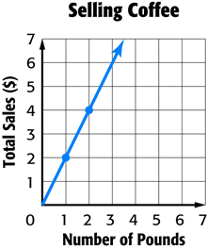
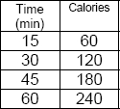
a. b.

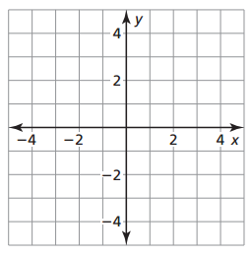
16. $2x+y=2$ a. Identify the slope:
Things to think about: “y-intercept”
- It is sometimes called the constant
- It is the starting amount or initial amount
- It is wherethe graph crosses the y-axis
- The x-value is 0: (0, b)
- It is b in the equation: y = mx + b
b Identify the y-intercept:
c. Graph the equation

Things to think about: “graphing linear functions”
- First: plot “b” on the y-axis
(b is the y-intercept, the constant)
- Use m to plot second point. From your first point, do rise/run with your m (slope) value.
- Draw the line that goes through the two points

17. Write the linear equations.
a. rate of change is 7,
y-intercept is -2
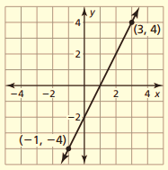
b.
Things to think about: “writing linear functions”
- Identify m (slope) and b (y-intercept: (0, #))
- Substitute the values into : y = mx + b

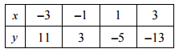
c.
Make sure you understand everything on this review. Attend tutorials with your teacher or in room D105 if you need help. Do your best and end the six weeks strong!

